MATH 2059

NUMERICAL METHODS

PROJECT#1

STUDENT NAME: OĞUZHAN BÖLÜKBAŞ

STUDENT ID: 150114022

STUDENT DEPARTMENT: COMPUTER SCIENCE ENGINEERING

QUESTION 1

In this question, we get coefficient matrix for polynomial, fence values for graph and numpoints which is also for graphing. After getting coefficient matrix, we generate an division array which is from the length of the coef matrix to 1 with incrementing one-by-one. We divide element-by-element the coefficient matrix with this division array. After this operations, we send the derivative coefficient array to polyval function in order to obtain integrated value of the polynomial. Like this, we obtain derivative of the polynomial function. We multiply the coef matrix with polynom’s degrees. Finally we plot graph of the function with integrated, derivative and normal values of the polynomial function. The graph is below:

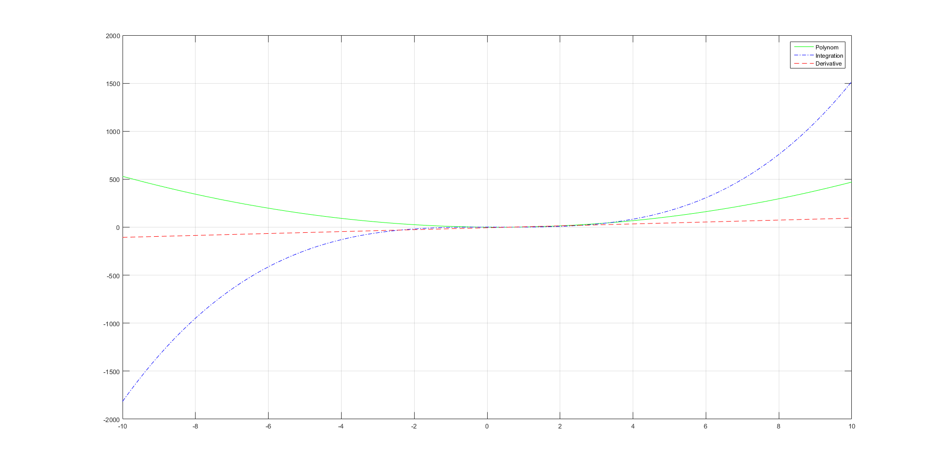

QUESTION 2

In this question, we have a function which is not presented in matlab format, it presented normally. Our aim is to plot of the function with calculating the values between given range. Firstly, we change normal multiply and division operators with element-by-element multiply and division operators. After this operation we can calculate result of the function. Plotting result of the obtained function is below:

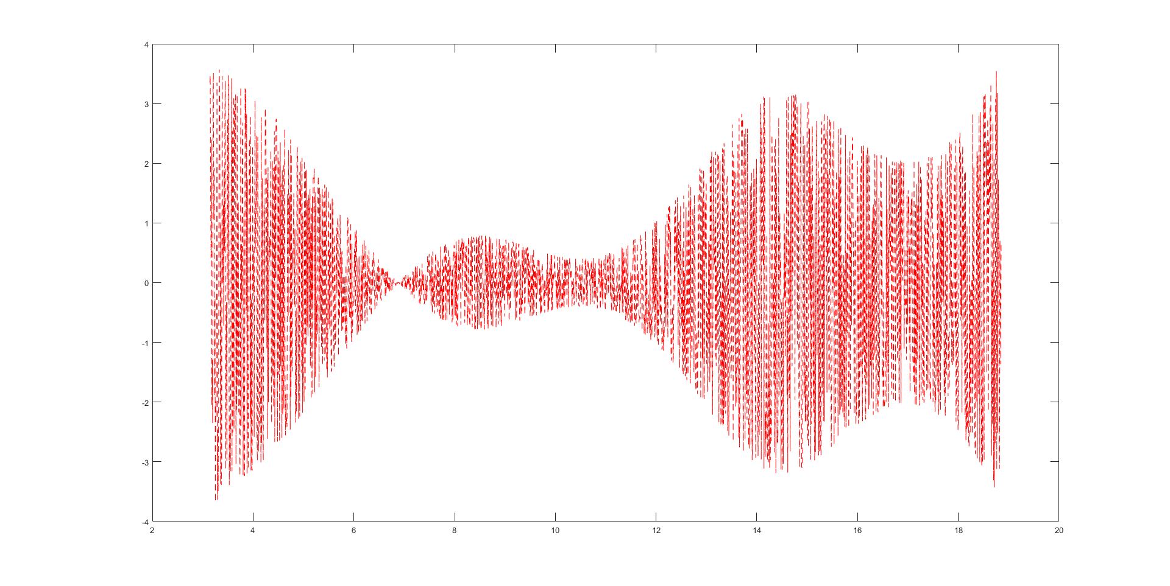

QUESTION 3

a) In this question, we implement a function named “mypi” which approximates the value of pi using Monte Carlo simulation. In order to estimate pi value, we generate x and y values between 0 and 1. After that, we check whether it is in the circle that’s radius is 1. With doing this, we generate 10, 100, 1000, 10000 times x and y values and count how many of them are in the circle. Thus, with multiplying this value with 4 and dividing with 10, 100, 1000, 10000 which is used, we estimate the pi value. Estimeted value are below:

mypi(10) = 3.200000000000000

mypi(100) = 3.000000000000000

mypi(1000) = 3.096000000000000

mypi(10000) = 3.140800000000000

b) Plotting result of absolute error between zpi and the real value of pi for 200 linearly spaced numpoints value between 10 and 10000 is below:

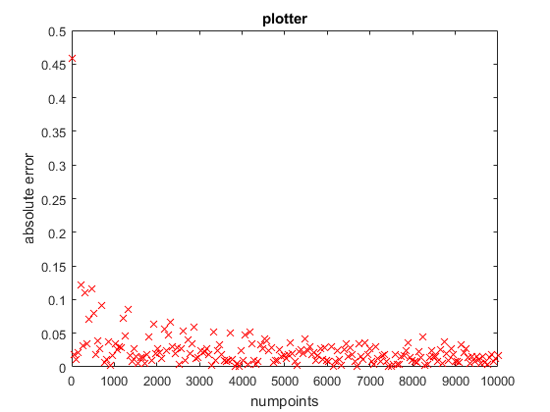

Question 4:

a) We find derivative of the given function in question 2 with using two, three, and five points methods for different h values(0.01 – 0.1 – 1). Result table is below:

|  |  |  |  |
| --- | --- | --- | --- |
|  | h = 0.01 | h = 0.1 | h = 1 |
| Two points method | -26.163571474449697 | -2.856634918522789 | -1.008820213726552 |
| Three points method | 0.034349884506017 | 0.271261927875744 | -0.487438407313024 |
| Five points method | 0.045509876496589 | 0.354498436416136 | 1.003150351666441 |

b) In order to find the derivative of the function, we calculate the area below of the function with different size quadrilateral. Results of the integrated function are below:

|  |  |  |  |
| --- | --- | --- | --- |
|  | h = 0.01 | h = 0.1 | h = 1 |
| Simpson’s Rule | -3.165391252592950 | -3.165391252592950 | -3.165391252592950 |
| Simpson’s 3/8 Rule | -0.035322099647737 | -0.353220996477366 | -3.532209964773664 |
| Trapezoidal Rule | -0.355692221065642 | -2.698106857588078 | 0 |